**PHYSICS PROJECT**

**WATER LEVEL INDICATOR**



Name: Anisha Goswami

Class:XII

Board:CBSE

Teacher’s Signature:

Remark:



**Pub-Boragoan, Guwahati – 781035**

**PHYSICS ACTIVITY**

Name of the Student : _________________________

Name of the Teacher :_________________________

Class : ____________ Stream : ____________

Roll number : ___________________

Registration Number : __________________

**Principal Signature**

**ACKNOWLEDGEMENT**

I would like to convey thanks to my teachers of Physics who gave their valuable suggestions and guidance for the completion of this project. I also express my gratitude to the Principal of this college for extending his generous patronage and constant encouragement. Finally, I am thankful to my parents for helping me economically and my friends for giving me a helping hand at every step of the project.

**CONTENTS**

1. Introduction
2. Circuit diagram
3. Working principle

**AIM**

To know the level of the water in water tank using transistor (npn).

**INTRODUCTION : -**

Water is very precious than Diamond. If diamond is lost, some amount will be lost but if water is lost, then our life will be lost, so, it is our prime responsibility to protect water. It is found that maximum amount of water is lost during filling the tank (water tank). So it is our great challenge to protect it. I realised it one day and thought to make a circuit which can detect the level of water in tank and also it alerts us when the water tank is fully filled. So, finally I have constructed a circuit of ‘Water Level Indicator’ let us observe, how the circuit works.

**(CIRCUIT DIAGRAM) : -**

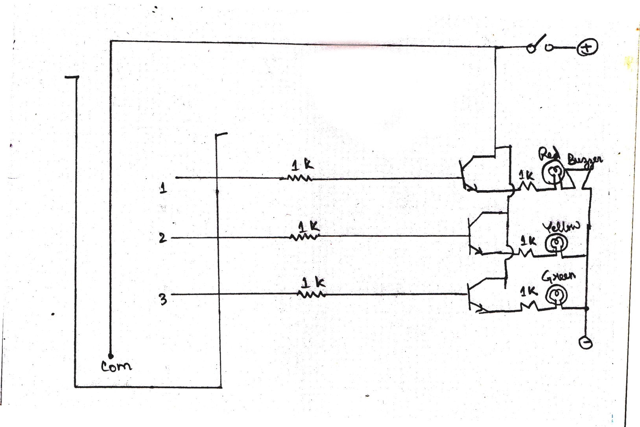

**WORKING PRINCIPLE :-**

The working of the circuit is very simple. When battery is connected with the circuit and water in the tank touches the sensor, current flows throughout the circuit. It flows through NPN transistor. When current flows through its base, the signal is amplified and it provides the circuit audio amplifier stage. That is the reason, when along with L.E.D we connect buzzer, sound is given out. Generally L.E.D. glows due to normal conduction process.

When water reaches Level (3) the green L.E.D. glows. When it reaches level (2) the yellow L.E.D. glows, and when water is filled totally, the red L.E.D. glows and alarm is given out which indicates that ‘Water tank is filled and we must switch off the motor to protect water loss’.

In this way, the circuit works.